Join the World’s Largest Truck Convoy®

Registration Packet

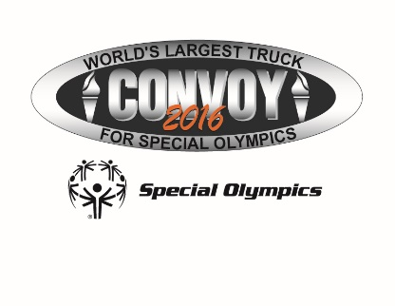

On Saturday, September 24, 2016 join the compassionate army of truck drivers as law enforcement officers escort the World’s Largest Truck Convoy® across the highways and byways of South Carolina to raise awareness and funds for Special Olympics athletes and change attitudes toward people with intellectual disabilities.

What is the World’s Largest Truck Convoy®?
The Truck Convoy® is a celebration of the trucking industry and its support of Special Olympics. It is a unique one-day celebration in which law enforcement makes special dispensation and escorts a convoy of trucks up to 30 miles through their respective towns.

Truckers will meet at the grounds of the South Carolina State Farmers Market 3483 Charleston Hwy. west Columbia, S.C.29172 and are escorted in a convoy on the busiest corridors of Columbia. On return to the State Farmers Market they are welcomed by the Special Olympics community - athletes, families, friends, colleagues, law enforcement officers and the organizations, companies and agencies that make up the trucking industry. A celebration - a picnic, a live DJ, dunk-a-cop dunking booth, jump castle, massages and games of all kinds is followed by an awards ceremony held to recognize participating truckers and the support of the trucking industry. Whichever form the celebration takes, the message is the same: “Thank you for your support of Special Olympics athletes and for keeping our communities moving!”
Families of all participants are welcome and will share in the celebration and free lunch!
Inspired by the powerful impact Special Olympics had on his life through his participation in the Law Enforcement Torch Run®, combined with his job duties as a State Transport Police officer and love and respect for the trucking industry, Mike Still, a Sergeant with the SC State Transport Police, organized the Truck Convoy, a one-day celebration of the trucking industry to help raise awareness and funds for Special Olympics South Carolina.

No matter where you find yourself on Saturday September 24, 2016, a Special Olympics Truck Convoy will be close by. Check out the web site www.worldslargesttruckconvoy.com for specific local event information.

INFORMATION

Vehicle Types Allowed
Semi-trucks, truck/trailer combinations, large trucks, low-boys, dump trucks, flat beds, buses, large tow trucks, large box trucks, etc. All trucks entering the convoy must be of 10-GVW or larger.

Event Location and Address
The Convoy will last from 8 a.m. to 2 p.m. All trucks and drivers need to arrive between 8 a.m. and 9 a.m. for registration and drivers meeting. The Convoy rolls out at 10 a.m.

Address: South Carolina State Farmers Market 3483 Charleston Hwy. West Columbia, S.C. 29172

Lead Truck Information
The Lead Truck will be determined the day of the Convoy. The company or driver that raises the most money will get the honors.

PROGRAM OF EVENTS

Activities include:
- Live DJ
- Dunk-A-Cop dunking booth
- Games
- Jump Castle
- Massages(From the Southeastern Institute Massage School)

Coffee and doughnuts will be offered that morning.
A free lunch will be offered for participants and their families and/or guest

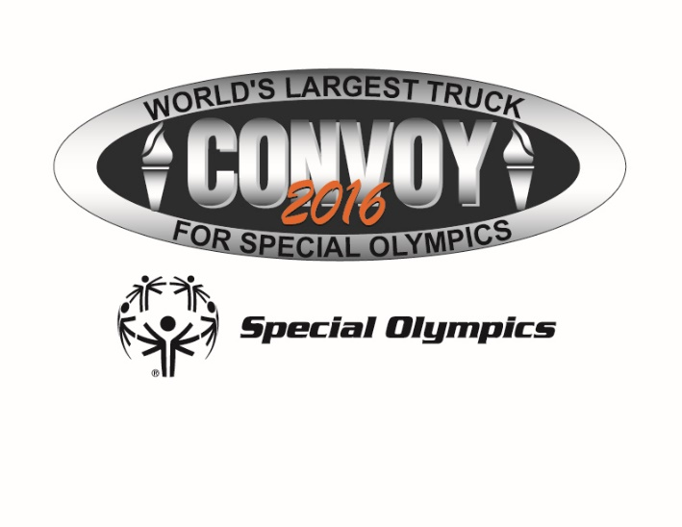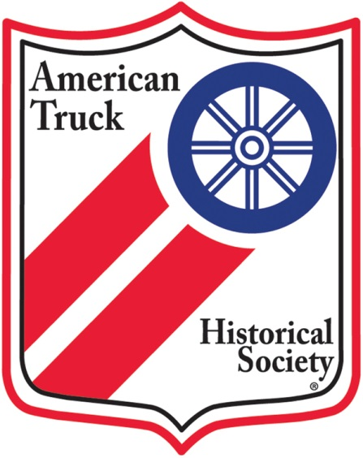

We are very excited this year to also have an incredible truck show along with the World’s Largest Truck Convoy for Special Olympics. The American Truck Historical Society, Palmetto Upstate Chapter has supported and participated in the WLTC for Special Olympics several years now. This year ATHS will also be joined by the Antique Truck Club of America Palmetto Iron Classic Chapter. ATHS and ATCA will display their incredibly beautiful antique trucks and tractors for convoy participants and guest to enjoy.
If you are a truck enthusiast or have your own antique or show truck you can join the fun with them. You can reserve your spot by contacting Phil Hyrnerko at 803-960-2528.

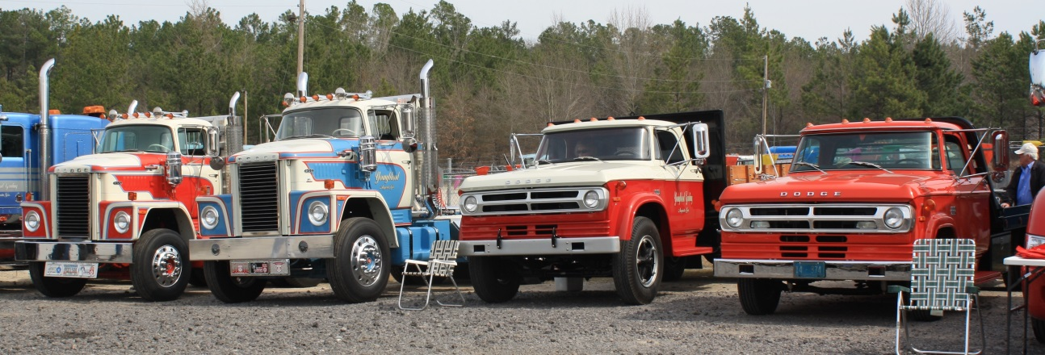

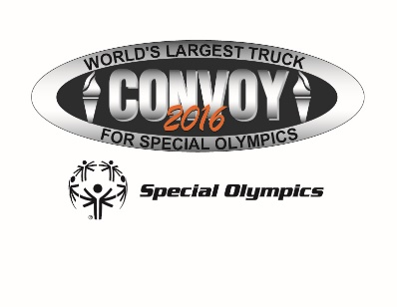

GUARDIAN SPONSOR
$2500 donation allows:
Up to 20 entries in the convoy, one of which will be designated to be in the top five or tail five. (First come, first served).
Company name or logo displayed at the event.
Lunch for corporate representative and/or participating drivers.
Personal invitation to press conference and presentation of your company’s contributions.
Opportunity to have company message read at the awards ceremony

CONVOY PARTICIPANT | PRIVATE DONATION
$100 allows:  One entry in the convoy  Lunch provided for the driver | Any private donation of $100 or more entitles the donating individual or driver to a convoy t-shirt and goody bag

GOLD SPONSOR | SILVER SPONSOR
$1000 donation allows:  Up to 10 entries in the convoy.  Company name or logo displayed at the event.  Lunch for corporate representative and/or participating drivers.  Personal invitation to press conference and presentation of your company’s contributions. | $500 donation allows:  Up to 5 entries in the convoy.  Company name or logo displayed at the event.  Lunch for corporate representative and/or participating drivers.  Personal invitation to press conference and presentation of your company’s contributions.

Lead Truck
Drivers and companies can raise funds to be the “Lead Truck” in the convoy (A great honor). It is very easy; just create your own fundraising page on Firstgiving. Then email or post it on social media to family, friends and coworkers and ask them to donate to you. The top fundraiser will get to be the lead truck and the second highest gets rights to be the final truck. You can create your page here: BELOW

https://www.firstgiving.com/so-sc/2016-Truck-Convoy

REGISTRATION FORM

Entries should be paid in advance to guarantee a position. A copy of proof of insurance of participating trucks should be submitted with this form.

Sponsorship Level
I, or my company, wish to participate as:
· Guardian Sponsor - $2,500 (No. of trucks: __)
· Gold Sponsor - $1,000 (No. of trucks: __)
· Silver Sponsor - $500 (No. of trucks: __)
· Convoy Participant - $100____

Company Information
Please list main company contact information in this section. The next page of this form should be completed and signed by each driver.

Company: ____________________________________________

Address: _____________________________________________

City: ________________________________________________

State/Province: _______ Postal Code: ________________________

Phone: ______________________________________________

Fax :(_____) __________________________________________

E-Mail:______________________________________________
Company Contact Name: __________________________________

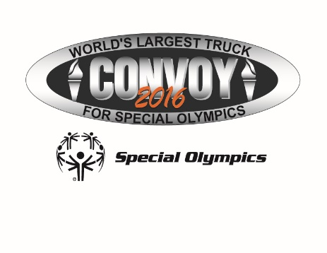

Method of PAYMENT:

Total Amount Due: US $ ________________________

Check enclosed made payable to Special Olympics South Carolina

Charge to: Visa MasterCard AmX Discover
Acc#:_____________________________ Exp. Date: __________Code____

Card Holder Nam: _____________________________________________

Signature: ____________________________________________

Please remember to include proof of insurance with this registration form.

Please make all checks payable to SOSC and return this page with your check to:
Special Olympics South Carolina
Attn: Truck Convoy, 1276 Assembly St., Columbia, SC 29201

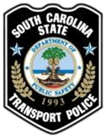

A copy of proof of insurance of participating trucks should be submitted with this form.
Driver Information
Please submit the following information for each driver participating in the Truck Convoy.
Each driver must verify that the following information is true and accurate. Make additional copies of this sheet as needed.
Company: _____________________________________
Driver Name: ___________________________________
Address: ______________________________________
City: __________________________St: ____________
Zip: _________E-mail: ___________________________

____I have a minimum of $1,000,000 combined single limit insurance for my vehicle
____I have the minimum insurance limits required in the above named state
____I have a Commercial Driver’s License.

By signing below, I certify that the information I have provided on this form is true and accurate to the best of my knowledge.
Driver Signature_____________________________
Date___________________________
Company: ____________________________________
Address: ______________________________________
City: __________________________St ________
Zip: _________________Cell #:____________________
Driver e-mail: _________________________________
Please submit this form with the company registration form and payment

